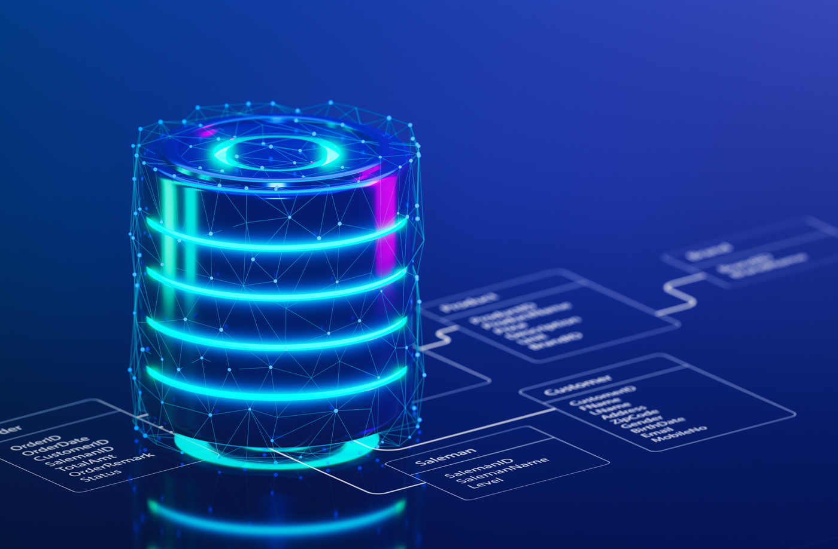

|  |  |
| --- | --- |
| **Name:** | **Waleed Afzal** |
| **Roll No:** | **23P-0566** |
| **Section:** | **4C** |
| **Lab:** | **DBMS** |
| **Number:** | **#10** |

**TASKS:**

**TASK#01:**

Created all Tables including Person, Employee, Purchase, Product.

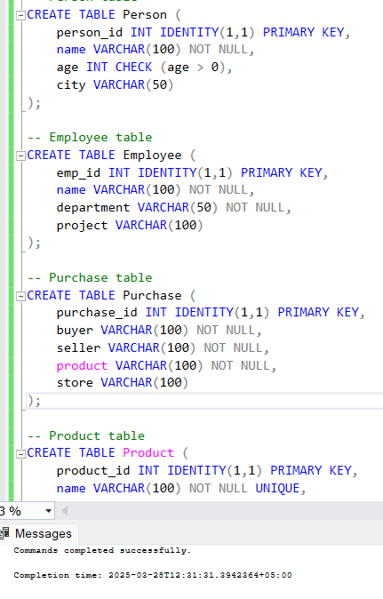

**Now creating Indexes:**

1. **Person Name Index:**

1. **Composite Index on age and city on Person Table:**

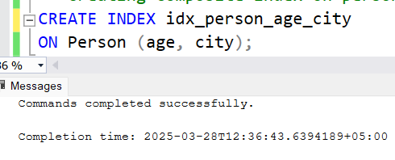

1. **Testing Queries:  
   i) Before Indexes:  
   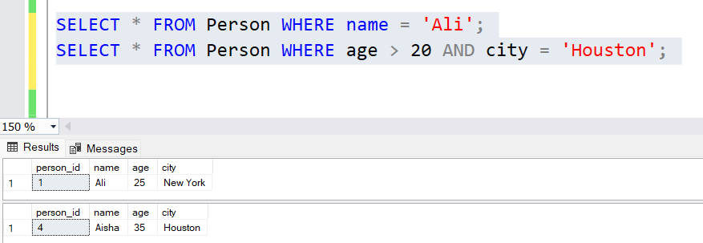**

**ii) After Indexes:  
**

**TASK#02 (Creating Views):**

**Creating Department Views AS Developers**

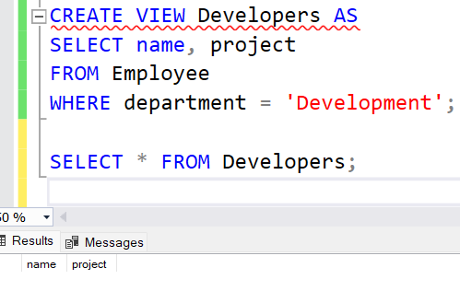

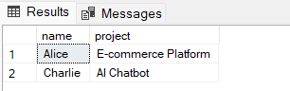

**Creating Purchase Views AS SeattleView**

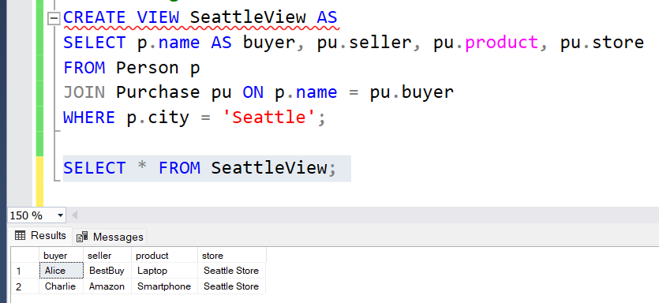

**Selecting From Views**

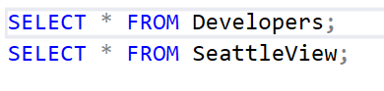

**TASK#03:**

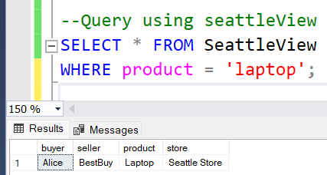

**Optimized Query:**

